**PRACTICAL – 7(2)**

**Aim: Write a program which takes N and number of threads as an argument.**

**Program should distribute the task of summation of N numbers amongst**

**number of threads and final result to be displayed on the console.**

**SOURCE CODE:**

import java.util.*;

class Mythread implements Runnable {

*int* n1;

*int* t1;

*int* c = 0;

*int*[] th1 = new *int*[200];

    Mythread(*int* *n*, *int* *t*, *int*[] *th*) {

        this.n1 = *n*;

        this.th1 = *th*;

        this.t1 = *t*;

    }

    public *void* run() {

        for (*int* i = 1; i <= t1; i++) {

            c = c + th1[i];

            System.out.println(th1[i]);

        }

        try {

            Thread.sleep(500);

        } catch (InterruptedException e) {

            System.out.println("error occured:" + e);

        }

    }

}

public class Practical_7_2 {

    public static *void* main(String[] *args*) {

        Scanner sc = new Scanner(System.in);

        System.out.println("Enter your number :");

*int* n = sc.nextInt();

        System.out.println("Enter your threads number:");

*int* t = sc.nextInt();

*int*[] th = new *int*[200];

        th[1] = n / t;

*int* sum = 0;

        for (*int* i = 1; i < t; i++) {

            th[i] = th[1];

            sum = sum + th[i];

        }

        th[t] = n - sum;

        System.out.println("The number is: ");

        Mythread b = new Mythread(n, t, th);

        Thread a = new Thread(b);

        a.start();

        try {

            a.join();

        } catch (Exception e) {

            System.out.println("Error occured :" + e);

        }

        System.out.println("\n20DCE019-Yatharth Chauhan");

    }

}

**OUTPUT:**

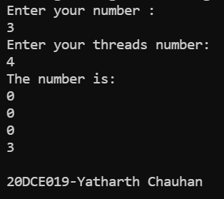

**CONCLUSION:** In this practical we creating the number of threads required by user as well as dividing the numbers to each thread on basis of input by user.